8 PRACTICE

Modern research programs

Modern research programs have several priority areas, the most important of which are the following: - the state of the grain market and the role of grain crops in the production of high-quality products; - precision farming; - resource-saving technologies and minimization of soil cultivation; - the use of plant growth regulators; - the problem of vegetable protein production and the role of leguminous crops in its solution; - the state and ways of increasing the productivity of field and meadow forage production. Let's consider some of them. Precision farming as the basis of resource-saving technologies in modern crop production. The modern world economy is undergoing significant changes, which are caused, among other things, by significant changes in the geopolitical map of the world that have occurred over the past fifteen years. The globalization of the economy, as well as the rapid development of technical and information innovations, poses a certain range of tasks for the economy of our country, on the solutions of which the position and role of Russia in the near future will depend. For example, Russia's accession to the WTO in the near future may have a detrimental effect on some sectors of our economy (for example, agriculture), at least in the state in which they are now. However, according to some estimates, Russia can play one of the leading roles in the global economy, despite the serious turmoil experienced from the post-Soviet period to the present day.
This requires a set of measures in tax, monetary, territorial, export-import and innovation policies. The introduction of new resource-saving technologies will provide; - access of countries with a high population density to resources; - development of interregional transport, trade and information infrastructure; - will ensure the security of countries. The development of resource-saving technologies in agriculture will allow the industry to reach a qualitatively new level of production, which will allow (with certain changes in the state policy supporting agriculture) agricultural producers to compete with foreign enterprises. One of the basic elements of resource-saving technologies in agriculture is "precision agriculture" (or as it is sometimes called "precision agriculture" - precision agriculture). Precision farming is the management of crop productivity, taking into account the intra-field variability of the plant habitat. Relatively speaking, this is the optimal control for each square meter of the field.
The purpose of such management is to maximize profits while optimizing agricultural production, saving economic and natural resources. This opens up real opportunities for the production of quality products and the preservation of the environment. This approach, as the international experience and experience of the Agrophysical Research Institute shows, provides a much greater economic effect and, most importantly, allows to increase the reproduction of soil fertility and the level of ecological purity of agricultural products. For example, a farmer from Germany, when introducing elements of precision farming, achieved an increase in yield by 30% while reducing the cost of mineral fertilizers by 30% and for inhibitors by 50%. For example, in 2007-2010. On the fields of the Menkovskaya Experimental Station of the Agrophysical Institute, using elements of precision farming, on sowing spring wheat, we saved about 20% of mineral fertilizers and got a yield 15% higher than with conventional technology (using the same technique). The yield reached 6.0 t / ha (this is already in terms of barn moisture - 14%)! At the same time, the quality of grain increased significantly - on sowing options where technologies of "precision farming" were used, we received wheat of the 2nd class, i.e. suitable for self-baking!
This result for the Leningrad region is the best proof of the effectiveness of technologies of "precision farming". Precision farming includes many elements, but all of them can be divided into three main stages: - collecting information about the farm, field, culture, region; - information analysis and decision making; - implementation of decisions - carrying out agro-technological operations.
To implement the technology of precision farming, modern agricultural machinery is needed, controlled by an onboard computer and capable of differentiated agrotechnical operations; precision positioning devices on the ground (GPS-receivers); technical systems that help identify field heterogeneity (Figure 1). These include automatic samplers, various sensors and measuring systems, harvesting machines with automatic accounting of the crop, remote sensing devices for agricultural crops, etc.
The core of precision farming technology (the second stage of those discussed above) is software content, which provides automated maintenance of spatially-attributive data from the card index of agricultural fields, as well as the generation, optimization and implementation of agricultural solutions, taking into account the variability of characteristics within the cultivated field. The first stage is well developed in terms of hardware and software. Soil automatic samplers equipped with GPS / GLONASS receivers and on-board computers are actively used abroad; geographic information systems (GIS) for compiling spatially oriented electronic maps of fields; yield maps of threshed crops obtained immediately after harvesting; remote sensing methods (ERS), such as aerial photography and satellite imagery. Together with the Agrophysical Research Institute (St. Petersburg), we use all of the listed components of information collection, we are engaged in research and development of our own methods and software. The second stage is currently the least developed, but there are a number of software products on the market designed to analyze the collected information and make production decisions. These are mainly specialized geographic information systems (GIS), programs for calculating fertilizer doses and much more. For example, these are SSToolBox ©, Agro-Map ©, Agromanager ©, LISSOZ ©, HarvestAgro ©, AdeptIS ©, Agrar-Office ©, as well as FieldRover II ©, MapInfo © and AgroView © and many others.
The stage of performing agro-technological operations, as well as the first stage, is developing dynamically. Here, the most "advanced" are operations for applying liquid and solid mineral fertilizers, as well as sowing grain crops. The application of fertilizers according to the technology of precision farming is carried out in a differentiated manner, that is, relatively speaking, we apply as much fertilizer per square meter as is necessary exactly here (on a given elementary section of the field). The deposit is carried out in two modes - off-line and on-line. It should be noted that the differentiated application of mineral fertilizers is currently a key element in precision agriculture (Figure 2). We can proudly say that we were one of the first in Russia to master and use this technology on our experimental fields. Off-line mode provides for preliminary preparation on a stationary computer of a task map, which contains spatially referenced, using GPS / GLONASS, doses fertilizers for each elementary section of the field. For this, the data on the field (spatially referenced) necessary for calculating the fertilizer doses are collected. The calculation of the dose for each elementary section of the field is carried out, thereby forming (in a special program) a task map. Then the task card is transferred on a chip-card (information carrier) to the on-board computer of agricultural machinery equipped with a GPS / GLONASS receiver and the specified operation is performed. A tractor equipped with an on-board computer, moving across the field, uses GPS / GLONASS to determine its location.
It reads the fertilizer dose corresponding to the location from the chip card and sends the corresponding signal to the fertilizer spreader (or sprayer) controller. The controller, having received the signal, sets the required dose on the fertilizer distributor. On-line real-time mode assumes preliminary determination of agricultural requirements for the operation, and the dose of fertilizers is determined directly during the operation. Agricultural requirements, in this case, are the quantitative dependence of the fertilizer dose on the readings of the sensor installed on the agricultural machinery performing the operation. For this, an optical sensor Hydro-NSensor manufactured by Yara © is used, which detects the content of chlorophyll in leaves and biomass in the infrared and red light ranges. Based on these data, as well as data on the variety and phenophase of the plant, the dose of nitrogen fertilizers is determined. To use the N-sensor (Hydro-N-Sensor), a portable Ntester instrument is also required, which determines the same parameters.
The results of the operation (doses and coordinates, treated area, time of execution and the name of the performer) are recorded on the chip card. In the on-line mode, the on-board computer receives data from the sensor, compares them with the determined and stored agricultural requirements, and sends a signal to the controller in the same way as in the off-line mode. Currently, various sensors are being actively developed that allow using the on-line mode. These are optical sensors that determine the nitrogen content in the leaves and the weediness of crops; mechanical evaluating biomass; electromagnetic and others.
Resource-saving technologies in crop production. There are technologies for soil cultivation, sowing and harvesting of grain, feed with a high content of exchangeable energy, which reduce the cost of diesel fuel by 5-10 times, labor by 3-5 times, the cost of grain and feed for dairy farming by 2-3 times. It is no longer something abstract, but the reality is Russia's accession to the WTO. How can agricultural producers survive in the common market with their expensive milk and meat? The high cost and low quality of the juicy and coarse - the so-called basic - feeds produced on the farms remain a problem for livestock breeding. In the structure of the prime cost of milk, they are decisive, as they make up about 60-70%. How to reduce the cost of feed production in the face of constantly rising energy prices? There should probably be an alternative to traditional costly technologies? She is! This is a zero tillage system. Today in most countries of the world it is known as No-Till, although the founder of the new technology is our compatriot, Russian scientist I.E. Ovsinsky, who back in 1899 published the results of his many years of scientific and practical work ("New farming system", Kiev, 1899.). N.A. also worked on this topic. Tulaykov, T.S. Maltsev, A.I. Barayev and other famous Russian scientists.
It turns out that with surface tillage to a depth of 5-7 cm (with the so-called minimum tillage - Mini-Till), natural drains formed by the decaying remains of the plant root system and the tubules formed by earthworms are preserved. The system of natural drains and canals makes the soil seem to be loose to a greater depth - greater than it happens with plowing, which is capable of letting air and moisture into the soil mass. The presence of air and moisture simultaneously in the soil accelerates the decomposition of crop residues, preventing an increase in acidity, increases the solubility (transformation into forms available to plants) in the excess of phosphorus, potassium, magnesium and other vital chemical elements present in the soil and necessary for plant nutrition. The moisture always present in the air condenses on the border between the treated and untreated parts of the soil - daytime soil dew falls out (the untreated part of the soil is always colder) - atmospheric irrigation occurs. Together with the daytime soil dew, the plants are supplied with a sufficient amount of nitrogen for their development in the form of compounds dissolved in the dew. Surface treatment of the soil to a depth of 5-7 cm allows you to reduce the need for mineral fertilizers, to get seedlings after sowing even without rain and crops even in drought. If the soil is plowed, the system of natural drains and tubules is destroyed, and the flow of air into the soil mass stops. The processes of decomposition of crop residues slow down, the acidity of the soil increases. For improper soil cultivation, one has to pay with liming and the application of mineral fertilizers. If the soil is plowed systematically, then during the passage of tractors, combines and agricultural machines, soil compaction accumulates to a sufficiently large depth, only the arable layer is loosened and thus a so-called "subsoil sole" is created, which does not let winter moisture into the soil massif. Figure 1 shows a section of the soil, where zones with different densities are clearly visible.
Melt waters are forced to drain from the surface of fields into ravines, rivers, dooming plants to drought, or are collected in "saucers", swamping the area. An example of such a process is shown in Figure 2 - spring, the snow has melted. Where it was not plowed - the moisture was absorbed into the soil, where it was plowed - the moisture saturated the arable layer and cannot go further, it is forced to evaporate, remaining on the surface of the field. Another very important factor: by abandoning plowing, we save a huge amount of diesel fuel - up to 70 ... 90% of the amount spent on mechanized tillage, sowing, care of crops and harvesting forage crops using traditional technologies! Gradually, you can abandon any kind of mechanical tillage at all - go to a zero tillage system - No-Till. Only sow and harvest! Move to No-Till gradually. Minimum (surface) tillage is carried out for two to three years. It is better to start this work in the fall.
The fields are treated with continuous herbicides, and after 2-3 weeks - continuous cultivation to a depth of 5-7 cm. If this is a layer of perennial grasses, then it is developed quite well in two or three passes of the cultivator. Then in the spring it is possible to carry out direct sowing on some of the areas without tillage. Within two to three years, the fields are leveled, the biological weed control system is being worked out. Each farm with its own set of crops and crop rotation has its own system, but the principles are common. When developing crop rotations, it is important to choose the right predecessors - biological nurses (allopaths). Experts know that mustard and rape are good allopaths.
Many other crops, such as rye, have allopathic properties. If the fields are heavily weed (after all, for many years we did not destroy the weeds, but plowed and then plowed them back to the soil surface - that is, multiplied them!), If the fields continue to clog up falling seeds (for example, grain), then the use of catch crops is very useful. To clear the fields of fodder crop rotation from weeds, compliance with the technology of harvesting fodder is also of great importance. For example, the highest content of metabolic energy in legumes is during budding and the beginning of flowering, in cereals - before heading. If you harvest feed within the specified time frame, then re-seeding will not occur.
With the right approach, the use of herbicides can be gradually minimized, and then abandoned altogether. In areas with below average rainfall during the year, it is imperative to chop up crop residues and spread them over the surface, covering the field with mulch like a blanket. Under such a “blanket” (Figure 5), moisture is well preserved, the growth of weeds is difficult, a crust does not form on the soil surface, and therefore the access of air to the soil does not stop. but it retains snow very well, contributes to the accumulation of winter moisture to obtain a future harvest, keeping winter crops from freezing.
Crop residues of maize with a height of about 0.4-0.6 m on the one hand create excellent conditions for snow retention, on the other hand, they reduce the content of hard-to-digest fiber in the gastrointestinal tract of cattle in silage and haylage, thereby increasing the feed value of the remaining feed. Within one to two years of minimal cultivation, the subcutaneous sole disappears, the soil revives: it begins to better retain winter moisture and allow air to pass through, and stops acidifying. A peculiar indicator of the beginning of soil “revitalization” is an increase in the number of earthworms per square meter of soil mass with a depth of 10-15 cm to 20-25 pcs. Some researchers call these little laborers field engineers. It is very useful to rotate narrow-leaved crops in the cold season (for example, cereals) with broad-leaved crops in the warm season (with corn) in the crop rotation. The fact is that, although the soil contains 100 to 1000 times more nutrients than is needed for plants, the forms available to plants are removed from the topsoil with the harvest.
Broad-leaved crops of the warm period consume a lot of moisture, they work as pumps, lifting moisture from the depths, and with it the nutrients available to plants dissolved in water. The use of mineral fertilizers is gradually decreasing to a reasonable minimum. According to the described technology, cereals, perennial grasses and annual grass mixtures, corn for silage with cobs and grain - practically all agricultural crops are cultivated. The results of numerous studies indicate that plant growth regulators play an important role in modern agricultural production technologies. Growth regulators are distinguished by a low consumption of the drug per unit of cultivated area, their use is aimed not only at increasing the yield, but also at improving the quality of agricultural crops and increasing plant resistance to unfavorable biotic and abiotic factors. It has been proven that plant growth regulators help to reduce the content of nitrates, heavy metals and radionuclides. It should be borne in mind that each of the drugs is intended to stimulate the growth, development and increase in productivity of certain crops at certain doses, timing and methods of application. Violation of these requirements can lead to a decrease in the expected effect.
Recently, more and more attention has been paid to non-toxic, highly effective plant growth regulators of a new generation - Kresacin, Silacin, Energia-M, which are approved for use in the territory of the Russian Federation for growing agricultural crops. The properties of organosilicon preparations are similar to those of zircon and epin. Organosilicon preparations are growth biostimulants that activate the germination of seeds of vegetable, grain and woody crops during pre-sowing seed treatment, which contributes to obtaining high-quality seedlings with a powerful root system. The use of plant growth regulators in arid and waterlogged regions significantly increases the adaptive properties and immunity of agricultural plants, increasing their yield and product quality. Considering that this increases the immunity of plants to unfavorable environmental factors, a number of diseases of fungal, bacterial and viral origin, it becomes possible to reduce the consumption rates of fungicides with their joint or separate use, as well as the frequency of treatments.
The new generation growth regulators have a triple effect on plants: stimulation of physiological processes, an increase in plant resistance to unfavorable factors and an increase in nonspecific immunity. The result of this action is to increase the yield and quality of the products grown. The manifestation of their action in extremely small concentrations made it possible to widely use them in the practice of agricultural production. Our country has cheap, reproducible, huge grassland resources that provide the main food for herbivores. But this potential is practically not realized. At the same time, large funds, technogenic and labor resources are invested in obtaining grain, 2/3 of which is used for fodder, as well as high-energy and protein feed on arable land. The consequence of this is the high cost and non-competitiveness of milk and beef production. The important role of grassland farming is due not only to large areas of natural forage lands, but also for economic reasons, first of all, the possibility of reducing total costs, especially non-renewable resources. It is known that the share of feed costs for pasture maintenance is reduced by half (up to 30% in the structure of total costs), fuel and lubricants costs are reduced by 6-7 times, equipment, labor and total costs for produced feed - by 2-3 times. compared with the stall keeping, which makes it possible to increase the profitability of dairy and beef cattle breeding by 1.5-2 times. It is also important that with pasture maintenance, metabolic processes and reproductive functions in animals are improved. Modern domestic technologies for improving hayfields and pastures, the effect of which is 80-90% or more achieved through the use of natural renewable resources, have great potential that has not been realized on a national scale and tested only in individual farms.
Meanwhile, with the improvement of natural fodder lands and the tinning of unused arable land, the size of which in Russia has grown by tens of millions of hectares in the last decade, it is possible to increase the productivity of hayfields and pastures by 3-5 times or more and obtain from them cheap, high-quality, rich energy, protein and vitamins. Regional systems of field fodder production also require intensification. Here it is necessary to increase the sown area for fodder crops, improve their species and varietal composition, master resource-saving technologies for their cultivation and rationally use plant raw materials. These measures will allow to double the gross production of fodder on field lands. The potential of scientific developments in feed production, created by scientists from the All-Russian Research Institute of feed and the network of research institutions coordinated by it, makes it possible to significantly increase the production of feed and improve its quality. The country's scientists have created highly productive varieties of forage crops, effective technologies for their cultivation and harvesting, storage in a long winter period and use with the greatest return.
Including developed and improved technologies for the preparation of bulky forage (hay, haylage, silage), increasing their quality by 15-25%, as well as technologies for preserving perennial grasses using a system of preservatives, including biological (enzymatic, polyenzyme, bacterial), chemical (organic and mineral acids) and complex (biological and chemical). This system of preservatives ensures the preparation and storage of feed, equal to the original mass in terms of nutrient digestibility, energy and protein nutritional value. Breeders of the All-Russian Research Institute of feed named after I. V.R. Williams, together with the All-Russian Research Institute of Agricultural Microbiology, effective methods of symbiotic selection have been developed that allow the creation of varietal microbial systems of forage grasses with microorganisms with increased symbiotic nitrogen fixation, productivity, habitat-forming and adaptive abilities for the production of environmentally safe, competitive agricultural products. The introduction of alfalfa and clover varietal microbial systems into fodder production on an area of ​​1 million hectares without additional material costs will increase the feed collection by 1.5-2.0 million tons (in terms of hay) and, due to the accumulation of biological nitrogen in the soil, will save nitrogen fertilizers (0.7-0.9 million tons).
A significant contribution has been made to solving the problem of moving many forage crops to the north, which is extremely important for the territory of Russia with its limited thermal resources. Our breeders have achieved remarkable success, creating early-maturing winter-hardy high-yielding varieties of meadow clover, alfalfa, perennial ryegrass, awnless rump, which ripen 15-30 days earlier than traditional ones and have little need for heat. These qualities of varieties have created new opportunities for organizing seed production. New varieties of meadow clover, alfalfa, perennial ryegrass, and awnless rump are much more efficient in using the natural resources of the northern regions than ordinary ones, and due to this they form 9-10 t / ha of dry matter, 2.5 -4 c / ha of seeds and pay off well the labor expended ... An important source of reducing the deficit of crude protein in concentrated feed is oilseed cakes and oilseed meals, including rapeseed - the most promising crop, which is not yet widely introduced into production. Scientists have created rapeseed varieties that meet international standards, including the Severyanin winter rapeseed variety, which is characterized by increased winter hardiness and sustainable seed productivity (3.5-4.0 t / ha). All-Russian Research Institute of Feed named after V.R. Williams seeks to unite the efforts of all research teams in the country to develop priority areas of feed production, including the development of recommendations for the development of this important industry in the regions of Russia. The development of forage production, including an increase in the share of grasslands, crops of perennial grasses, legumes and fodder grain, will optimize the structure of sown areas in the country, reduce the cost of financial, material, technical and energy resources in Russian agriculture by 20-30%.
to optimize the structure of sown areas in the country, to reduce the cost of financial, material, technical and energy resources in agriculture in Russia by 20-30%.

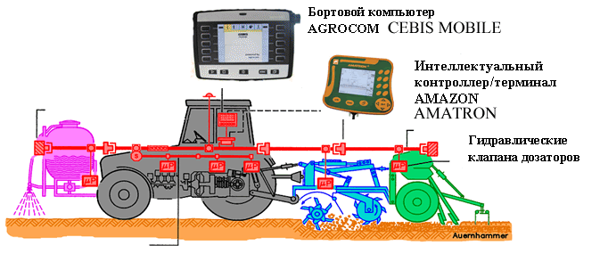
Figure 9 - Differential application system

In the process of operation by means of software, technological application maps are drawn up based on the results of agrochemical surveys and maps of field yield. The received information is transferred to the on-board computer by means of a chip card. Based on the received application card, the system provides automatic control of the dispensers via the mobile terminal of the unit. The positive effect of the introduction of the system: a decrease in the amount of fertilizers and chemicals spread and an increase in yields.
2.2. Agricultural land monitoring
An electronic map of fields makes it possible to maintain strict accounting and control of all agricultural operations, since it relies on accurate knowledge: field areas, length of roads, information about fields, etc. Based on the map of fields, a complete analysis of the conditions affecting the growth of plants in this particular field is carried out ( or even in areas of 100 × 100 m or 10 × 10 m). Field maps form the basis for obtaining a crop rotation structure and serve to optimize production in order to maximize profits, as well as rational use of all resources involved in production. Electronic maps of fields make it possible to accurately plan, record and control all agricultural operations, since they rely on the objective dimensions of the area of ​​the fields, the length of roads and other objects applied to it in the process of creation. permissions; - bypassing field boundaries using GPS equipment and special software; - combined method - a reasonable combination of the first two. Within the framework of an integrated management system for an agricultural enterprise, electronic field maps are used to account for crop rotation, to monitor moving objects, to organize transportation, to map crop yields, to study soils, for statistical and thematic data analysis, for planning the production process, etc.
2.2.1. Field working area monitoring
Territory surveys are carried out using a satellite global positioning system (GPS). Actual field boundaries are determined from the GPS receiver data. The measurement accuracy is determined by the type of GPS receiver used and additional equipment. The following accuracy classes are distinguished: - navigation - 5-7 meters; - autonomous mode of the precision driving system - 1-3 meters; - with differential service EGNOS - 15-30 centimeters; - with Omnistar VBS differential service - 15-20 centimeters; - with differential service Omnistar HP / XP - 5-10 centimeters; - the use of base stations RTK - 1-3 centimeters. Differential service of the European EGNOS system is free of charge. Its signal can be received by a simple GPS receiver with the corresponding function. However, EGNOS is currently in test mode, so it may operate intermittently. Guaranteed differential service is a paid service. It is possible to use the European Omnistar. Depending on the type of subscription, Omnistar provides several levels of accuracy: VBS and HP / XP. A subscription to VBS costs up to 1,000 euros per year, or 3 euros per hour (if you order at least 150 hours), but this service applies only to the European part of Russia. HP / XP provides an accuracy of 5-10 cm. An annual subscription to HP / XP costs an order of magnitude more. To use the VBS and HP / XP service, you must have a GPS receiver that supports these services, or upgrade your entry-level GPS receiver with a special antenna and software.
The highest level of accuracy, 1-3 cm, is achieved with RTK (Real-Time Kinematics). To ensure this mode, it is necessary to purchase and deploy base stations. Field measurements can be performed by mobile systems - a laptop with a connected GPS receiver and special software, or remotely. For remote measurements, you can use an extensive equipment monitoring system. The choice of option is determined by the requirements for the accuracy of measurements and the promptness of their implementation. Functionality of the field monitoring subsystem: creation of custom field maps in vector format, correction of current field maps with clarification of their boundaries, splitting or combining; input of GPS data with quality control according to the number of satellites used in operation and the geometry of their position, which affects the accuracy of positioning; display on the map in real time received from GPS data; measuring distances and areas on the map; determination by simplified technology of the part of the field processed by agricultural machinery; correction of accompanying information for each field (Figure 10).
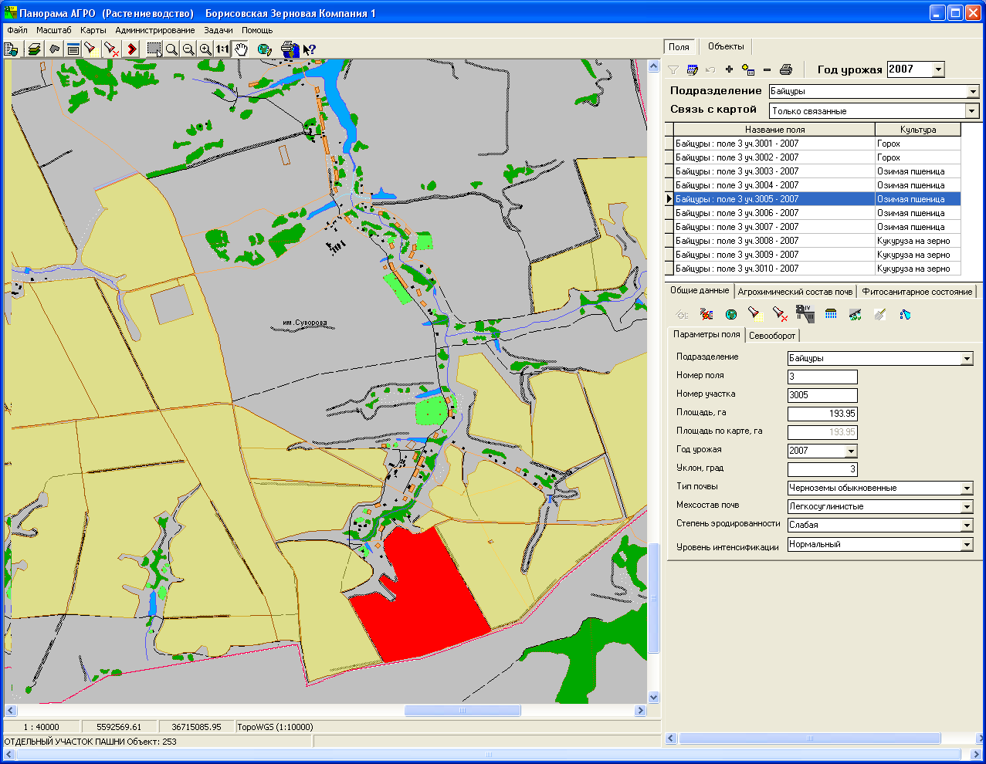

Figure 10 - Field information obtained using a GPS receiver

